TFT1P5111-E
APPLICATION NOTE

This application note is only for reference and maybe changed without any notice .
Please contact TRULY R&D department for update files and product status before design for this product or release the order.

WRITTEN BY | APPROVED BY
Huang ChunNing | Yang LiQiang

■ APPLICATION CIRCUIT

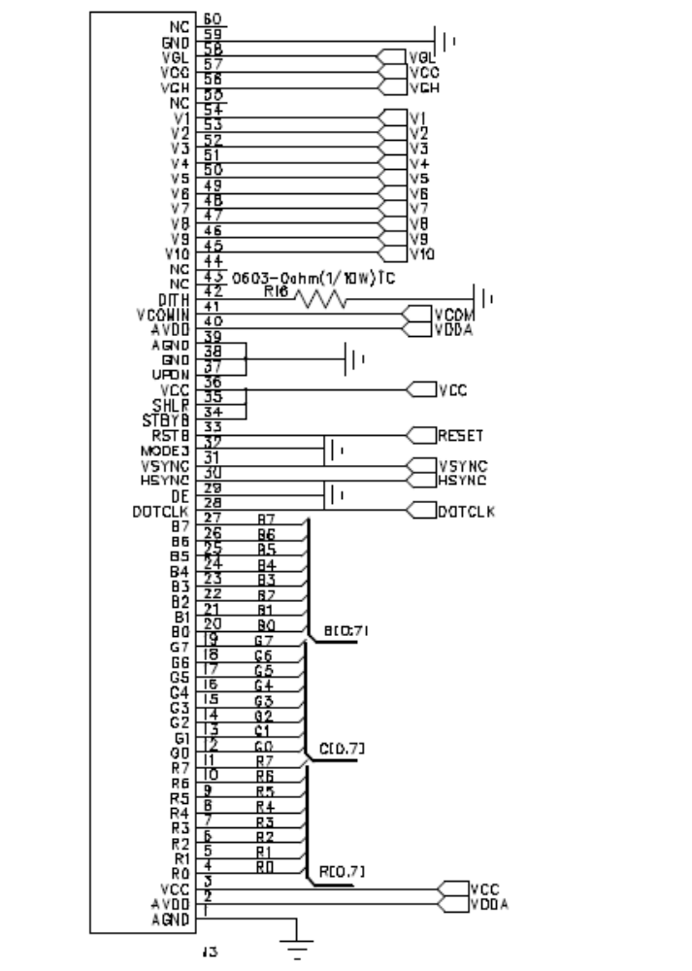

NOTES:
1 LED forward Voltage(Vf) = 10.5V typical。
2 Back-light LED Current(If) = 140mA typical,

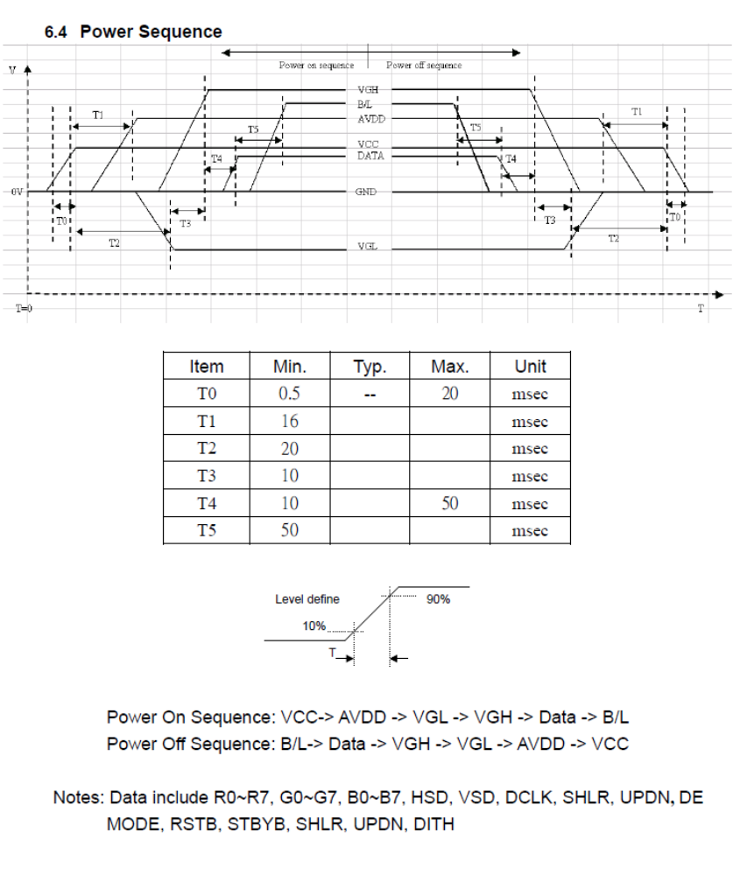

■ TIMING CHART
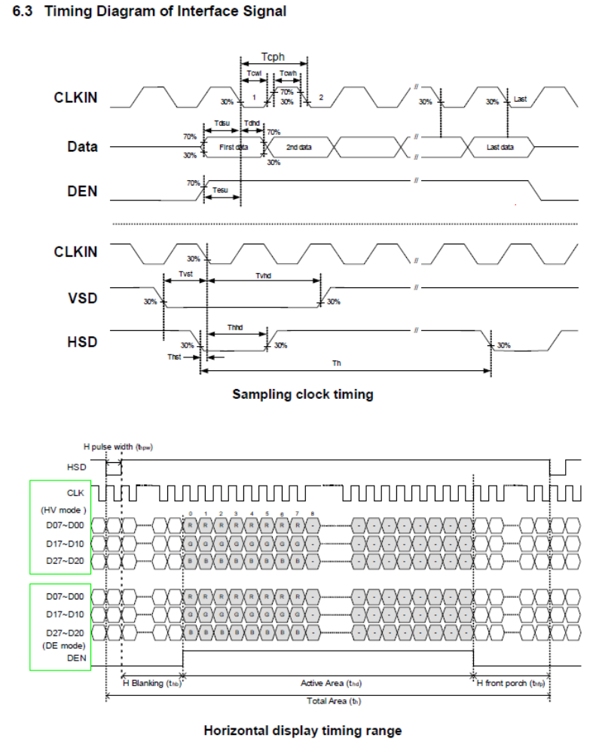

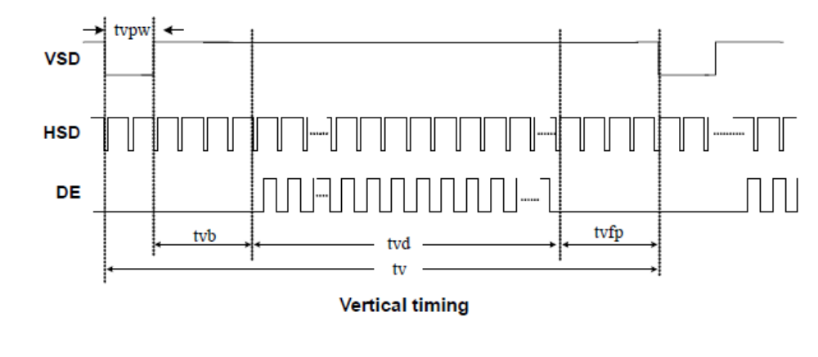

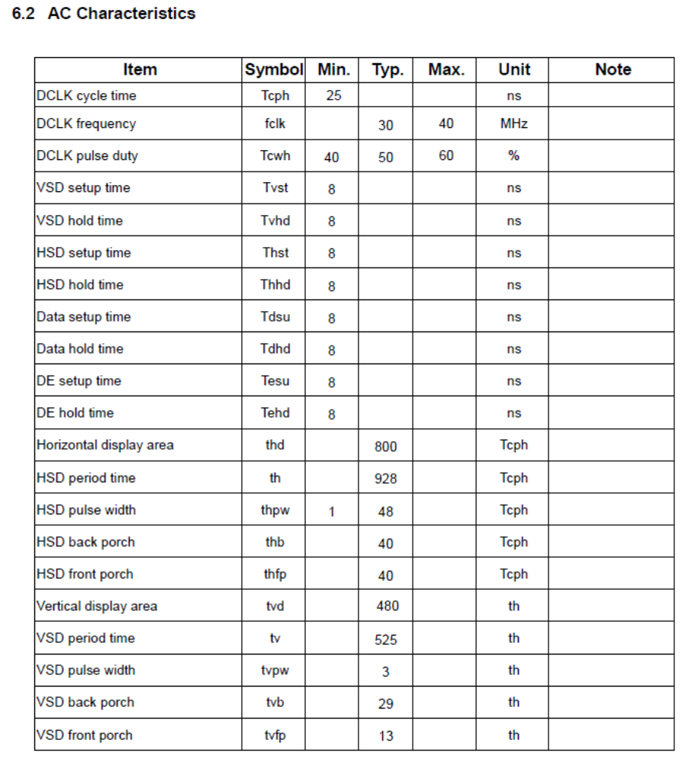

- ELECTRICAL CHARACTERISTICS
Here are the driving voltage for reference.
VDD | 3.3
VGH | 16.0
VGL | -6.60
VDDA | 10.6
VCOM | 3.65
V1 | 9.2
V2 | 8.0
V3 | 7.0
V4 | 6.5
V5 | 5.13
V6 | 3.53
V7 | 3.0
V8 | 2.51
V9 | 2.25
V10 | 0.45

